Experiment 17
Aim
To write a Prolog program to find the sum of integers from 1 to N.
Algorithm
- Start.
- Read the value of N.
- If N = 0, the sum is 0.
- Otherwise, recursively find the sum from 1 to N-1.
- Add N to the recursive result.
- Display the sum.
- Stop.
Code:ss
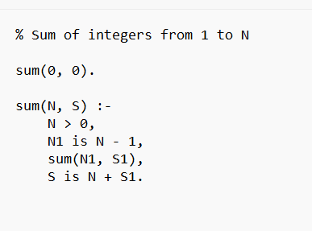
Output:
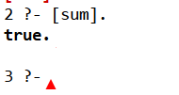

Result:
Thus twrite a Prolog program to find the sum of integers from 1 to N

